**Assignment no. 1**

**Data Structures and Algorithms Lab**

**Name**: Saad Nisar Butt

**Reg. No.**: cs211246

**Class**: BSCS 3C1

Implement method to join 2 doubly linked list.

**Method Code:**

public void combineTwoLists(DoublyLinkedList list1, DoublyLinkedList list2) {  
 list1.tail.next = list2.head;  
 list2.head.prev = list1.tail;  
 list1.tail = list2.tail;  
}

**Output**

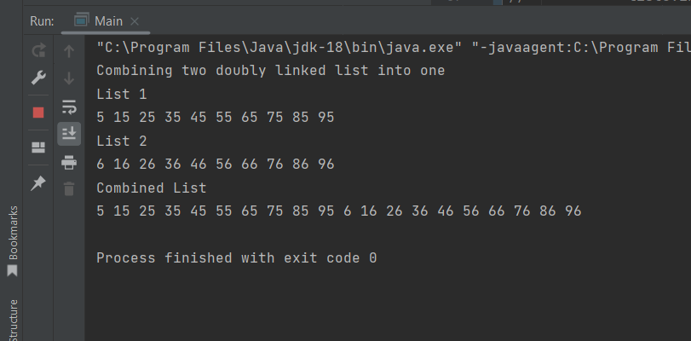

Implement two way search on doubly linked list.

**Method Code:**

public boolean twoWaySearch(int key) {  
 if (key == head.data) {  
 return true;  
 } else if (key == tail.data) {  
 return true;  
 } else {  
 DoublyNode currentHead = head.next;  
 DoublyNode currentTail = tail.prev;  
 while ((currentHead != currentTail) && (currentHead.prev != currentTail.next) && (currentHead.prev != currentTail))  
 {  
 if (key == currentHead.data || key == currentTail.data) {  
 return true;  
 }  
 currentHead = currentHead.next;  
 currentTail = currentTail.prev;  
 }  
 if (key == currentHead.data || key == currentTail.data) {  
 return true;  
 }  
 }  
 return false;  
}

**Output**



